A simple 10 W stereo amplifier
This project evolved from the successful 10W quasi class-AB power amplifier which has been described elsewhere on this page. The author has made several of these amplifiers which are very versatile and can be realised for different output powers depending on the power supply voltage: certainly up to 20W. These amplifiers can also be configured for different voltage gains, obviating the need for separate pre-amplifiers. The author has configured as stereo set ups using discrete amplifiers with excellent results.
The next logical step was to build a stereo amplifier within a single chassis and with a common power supply. The first build was to configure an amplifier for solely CD player use since I do not have an active turntable and no vinyl anymore. The input voltages are very different for a CD player and a turntable pick-up cartridge: 2V compared with perhaps 5 mV respectively. Now the basic amplifier can be configured for various voltage gain depending on the selection of the resistor marked ”R” which is in series with the 220uF capacitor connected to the emitter of Q1 (BC557) so the gain is approximately equal to the ratio of the 4.7 k resistor divided by R, plus 1. I use a 180 ohm resistor for R in the CD player version which equates to a voltage gain of 27. This is equal to about 350 mV input for maximum output power. In order to feed a signal from a turntable you need about 5 mV and hence a great deal of gain. The value of R in this case would be something in the order of 5 or 10 ohms. (This requires something like a stage gain of perhaps 1800 or so). It would be very simple to arrange a switchable resistor version. However the standard wisdom is that you add a free-standing pre-amplifier feeding the power amplifier which adds more cost, greater complexity and noise. I like to keep it simple.
Figure 1 depicts the circuit schematic for the CD player version. (Only one amplifier shown). Note that I have incorporated a 25k potentiometer across the input which seems to work well. This amplifier is also fitted with standard RCA input connectors. Note also there is no balance control and no bass/treble controls – again keep it simple. Speaker load is 8 ohms.
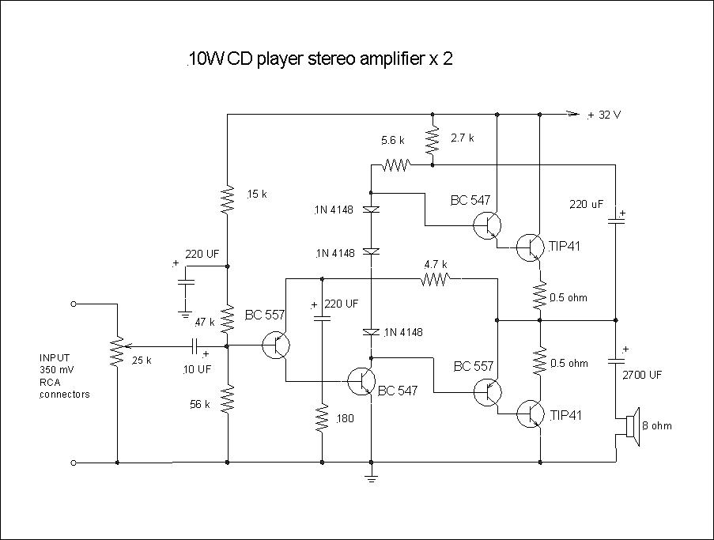
Figure 1 CD version configuration
Figure 2 shows the basic amplifier component layout. Note that the power transistors are shown as being directly connected to the tag strip lugs for convenience. However they should have flying leads so as to be connected to the heat sinks. Note also that there are one and a half tag strips taped together with duct tape.
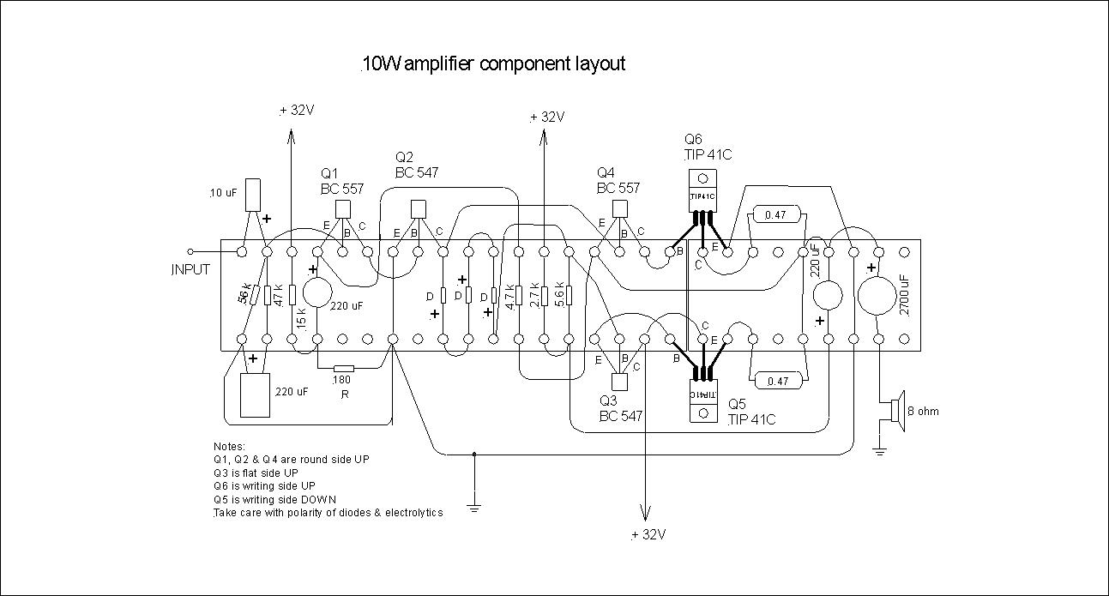
Figure 2 Basic amplifier component layout
The next version contains an integral single stage pre-amplifier which is switchable for either CD player or phono turntable operation. This does not add greatly to the complexity. A double pole double throw (DPDT) switch should be satisfactory). Again there is no balance control and no bass/treble controls. It is assumed that the turntable has a moving magnet pick-up cartridge rather than the more sensitive moving coil type. The voltage gain for the pre-amplifier stage is about 64. The schematic diagram is depicted in Figure 3, and I have built and tested a pre-amplifier to this design which will take a maximum input signal of about 13 mV feeding the main amplifier for an output of about 10.5V without clipping which equates to an output power of about 13W. However I have not built a complete stereo set complete with switching as yet.
The pre-amplifier is of the self-bias type which means that the design is sensitive to the transistor hFE, however in this instance this should not be a problem since the amplifier is capable of delivering an output of 10 V, way more than needed. I opted for this design to minimise the component count rather than using the classical voltage divider type. It might be better to use a 2N3904 instead of a BC547, but not critical. The BC 54X series tends to have a higher hFE. (In fact the transistor I found to make the prototype was a BC548 with an hFE of 349 and the base/collector bias resistor used was 10M).
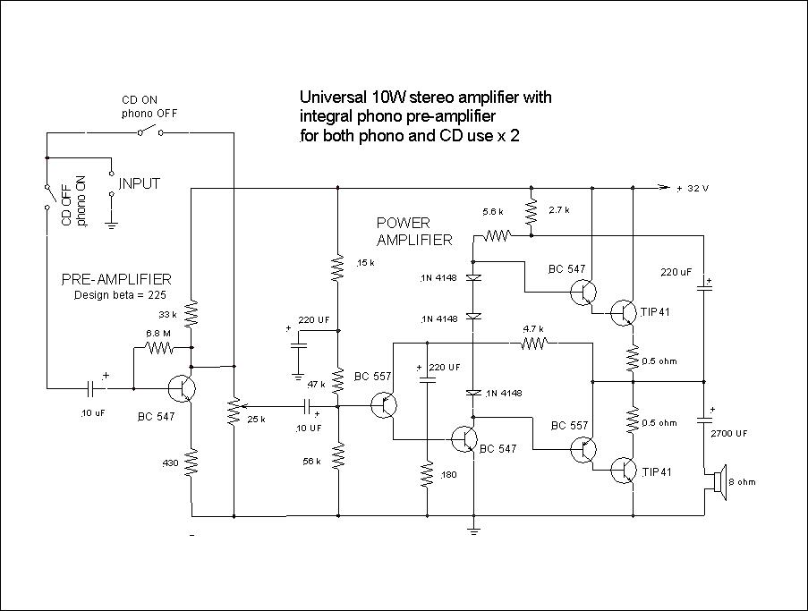
Figure 3 Composite Phono/CD player configuration
To achieve 10W output power for each channel you need a power supply loaded voltage of about 32V (unloaded is about 36V) with a maximum DC power of around 40W. (I use a power transformer output of 24 VAC rated at 60 VA with a full wave bridge rectifier and 3 x 1000 uF smoothing capacitors in parallel with no apparent 100 Hz quiescent hum. The reason for having multiple capacitors is a protection measure in case one fails, rather than having a single, more expensive one).
Some care is needed to adequately shield the input signal cables particularly if building a system with a phono input. I use microphone screened cable.
Figure 4 depicts another simpler possible phono/CD player version which has switchable gain resistors as discussed above. One single pole double throw (SPDT) switch is required. This configuration has now been successfully tested.
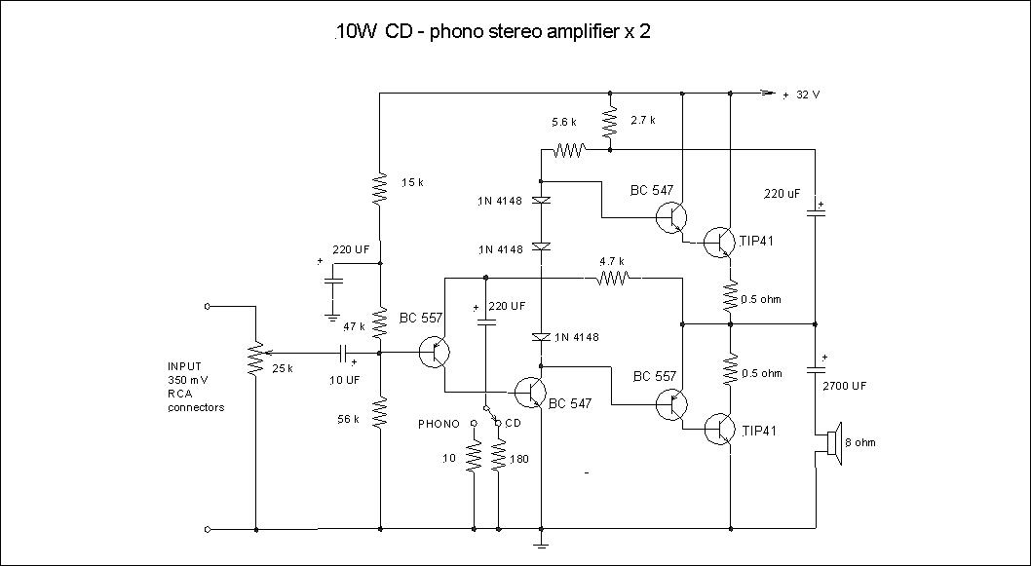
Figure 4 Simple phono/CD version
Figure 5 shows a photo of the CD amplifier version
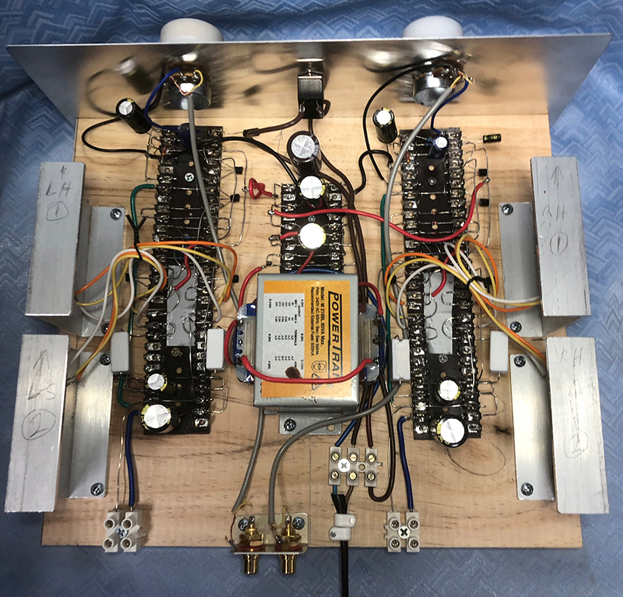
Figure 5a CD version rear view
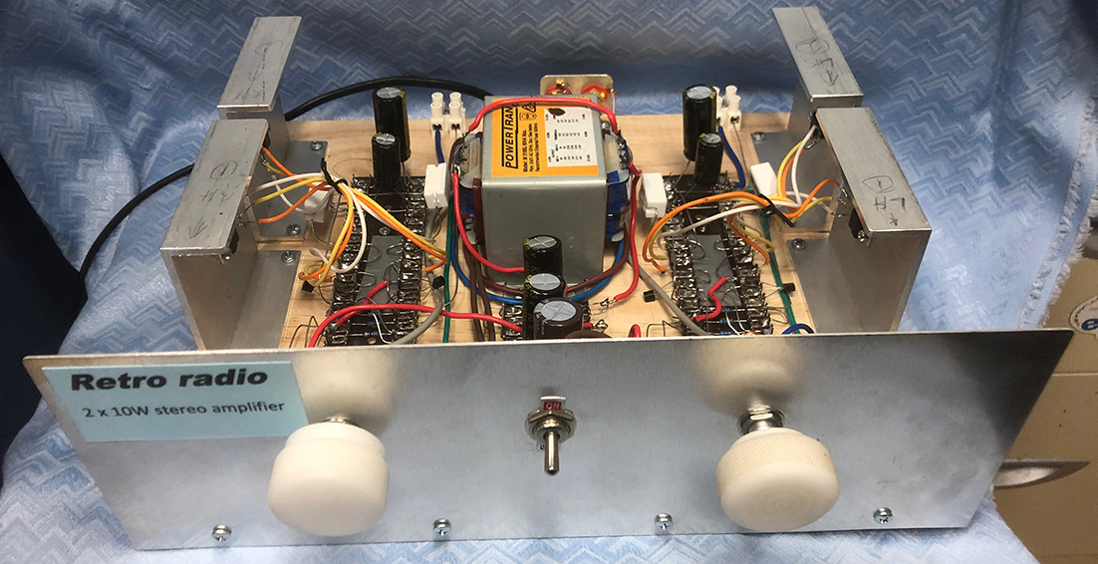
Figure 5b CD version front view
Both the CD/phono versions described above require physically changing the input cables which would probably be annoying if you regularly use both input devices. Figure 6 depicts a simple switch box which allows both devices to be permanently connected. You need 6 x RCA chassis-mounted female sockets and 1 x DPDT switch.
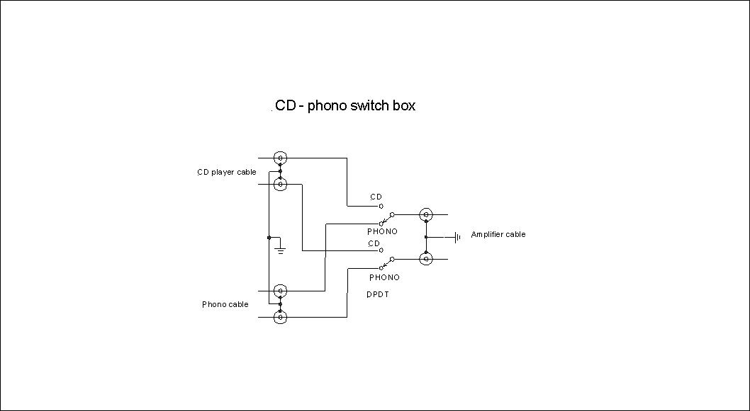
Figure 6 CD player/phono switch box
So we have described 3 different stereo amplifier versions all from the same base design.

John Clark ARMIT john@ausbow.com.au
March 2023

