A high performance shortwave regenerative receiver
This project outlines a simple Armstrong type regenerative short wave receiver after Charles Kitchin N1TEV based on the article entitled “High Performance Regenerative Receiver “published in QST Nov/Dec 1998. The article contains an extensive history of the evolution of the regenerative receiver together with a circuit called the junk box special and a high performance version. Both versions included CW and SSB clarifiers. The junk box special also featured band switching while the high performance uses plug in coils. Both circuits also incorporated an integrated circuit for the audio output. I decided to make the high performance version but omitting the CW and SSB options and also the ICs. I have an aversion for ICs and wanted to incorporate an audio pre-amplifier of my own design. I am only interested in DX (distance broadcast listening).
The basic circuit uses a RF pre-amplifier BJT with a FET as the regenerative detector. There is also a fine tuning variable capacitor in parallel with the main tuning which obviates the need for a vernier control. I also fitted a fine tuning variable capacitor for the regeneration control.
Figure 1 depicts the complete circuit schematic less the audio pre-amplifier.
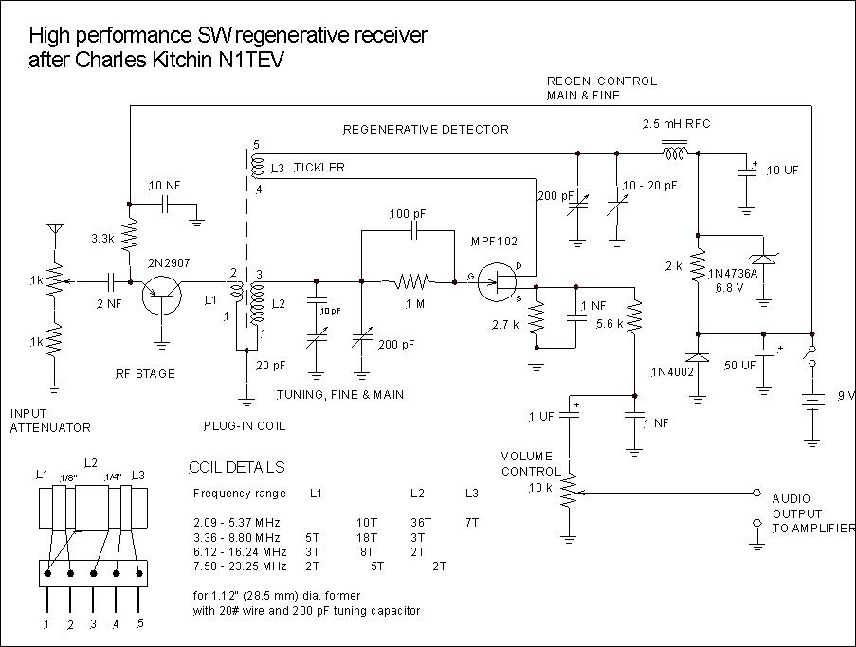
Figure 1 Circuit schematic
I make my own plug and sockets for the coils. (Fortunately I have both a milling machine and lathe). Of course you can use commercial coil plug-ins. I think that band switching is too complex and plug-in coils allow easier coil trimming. Figure 2 shows a typical coil unit and socket.
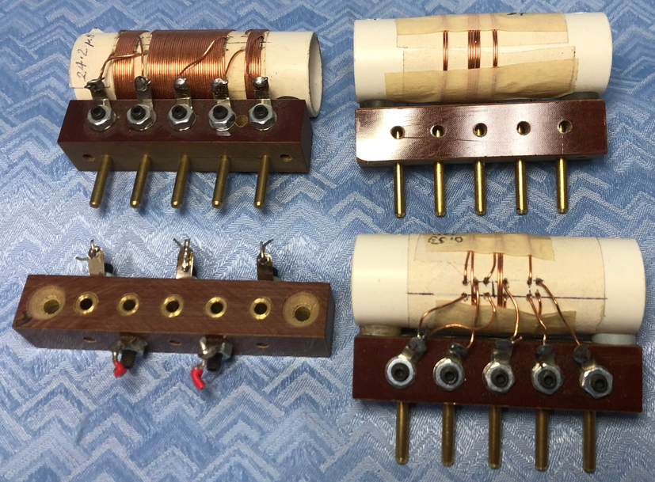
Figure 2 Typical coil units and socket
Table 1 contains the coil details.
Frequency range  MHz | Antenna winding  L1 | Tank coil  L2 | Tickler winding  L3
2.09 -5.37 | 10T | 36T | 7T
3.36 – 8.80 | 5T | 18T | 3T
6.12 – 16.24 | 3T | 8T | 2T
7.50 – 23.25 | 2T | 5T | 2T
All use 1.12” OD (28.25 mm) PVC former with 20 gauge enamelled copper wire and 200 pF variable capacitor.
Table 1 coil details
I find the most useful coil is number 3 (6.12 – 16.24 MHz) for broadcast stations.

Figure 3 depicts a 2-stage self-bias audio pre-amplifier which should support headphones or drive a 1 W power amplifier. I use a power amplifier designed by Harry Lythall.
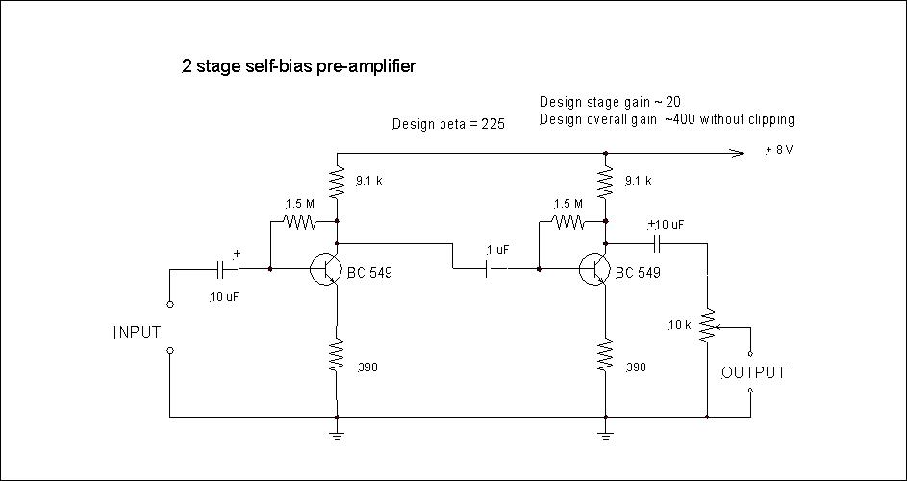
Figure 3 A 2 stage self-bias audio pre-amplifier
I normally build circuits using old-fashioned tag or barrier strips with a wooden base and breadboard type construction with an aluminium or Laminex front panel. I prefer not to use aluminium chassis construction, particularly at VHF. For this receiver I made a hinged wooden box cover which allows easy access to the plug-in coils. The box has simple pin hinges using wood screws at the rear of the baseboard. For this build I used 2 x 18 row barrier strips mounted one over the other with the upper board as the audio amplifier on stand-offs and the receiver board below. The coil was mounted at the rear. Figure 4 shows a photo of the inside layout. Note the homemade disc variable capacitors for fine tuning.
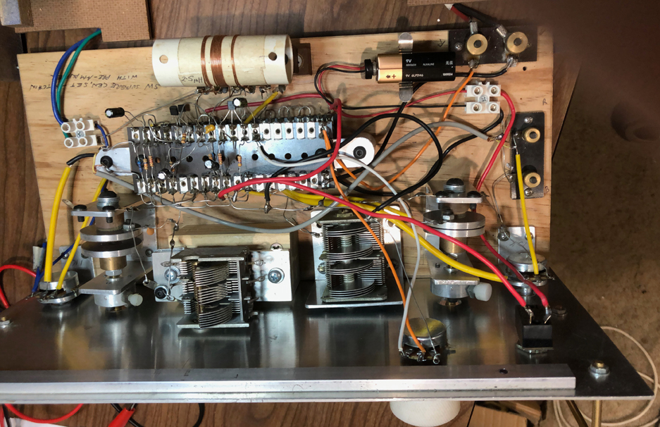
Figure 4 Inside layout
Figure 5 is a photo of the front panel complete with homemade knobs and tuning scale.
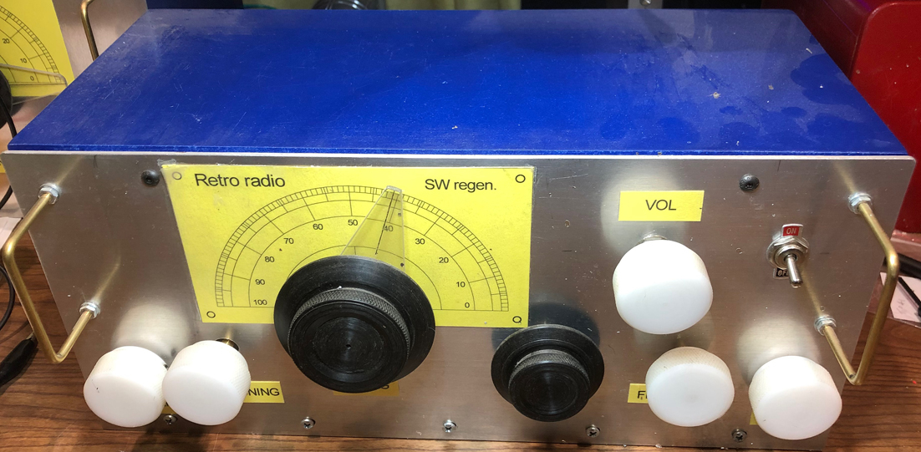
Figure 5 Front panel
The receiver is very sensitive and has good selectivity when connected with a random long wire antenna and good earth. This is by far the best SW receiver I have made. Thanks Charles.

John Clark ARMIT January 2023
john@ausbow.com.au

