An RF probe and voltmeter
Measuring voltage at RF requires some expensive and difficult to source meters. This article describes making a simple RF probe which can be used in conjunction with a digital multimeter (DMM). The probe design is courtesy of Jim Tregellas VK5JST in his article entitled “ An RF Voltmeter for Transceiver Servicing”, http://www.users.on.net/~endsodds/rfvm.htm.
The RF detection utilises a Schottky diode and the probe can be used at frequencies up to about 200 MHz.
The circuit schematic for the probe is depicted in Figure 1.
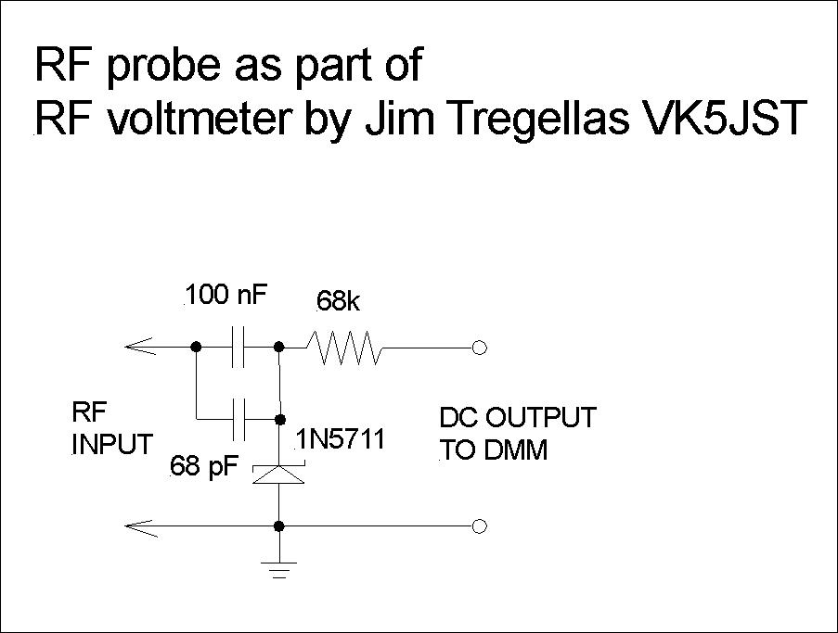
Figure 1 Detector schematic
I built two units, one as an RF probe and a second mounted in a small box with a BNC connector. Figure 2 shows the probe version and Figure 3 has the other. Both versions have 4 mm banana plugs for the DC outputs. The probe is useful for in-circuit measurements while the box version is good for checking signal generator outputs and other coaxial connectored devices.
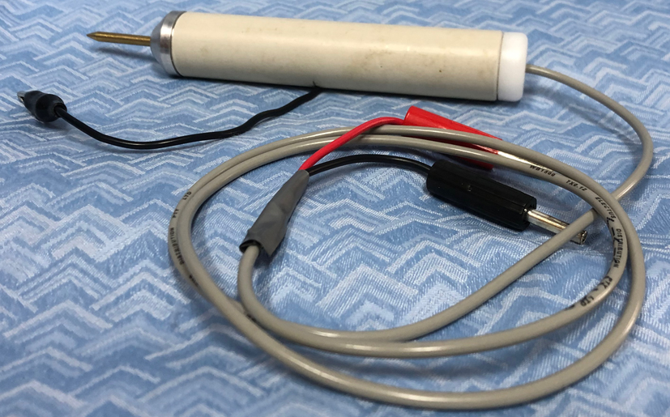
Figure 2 RF probe version

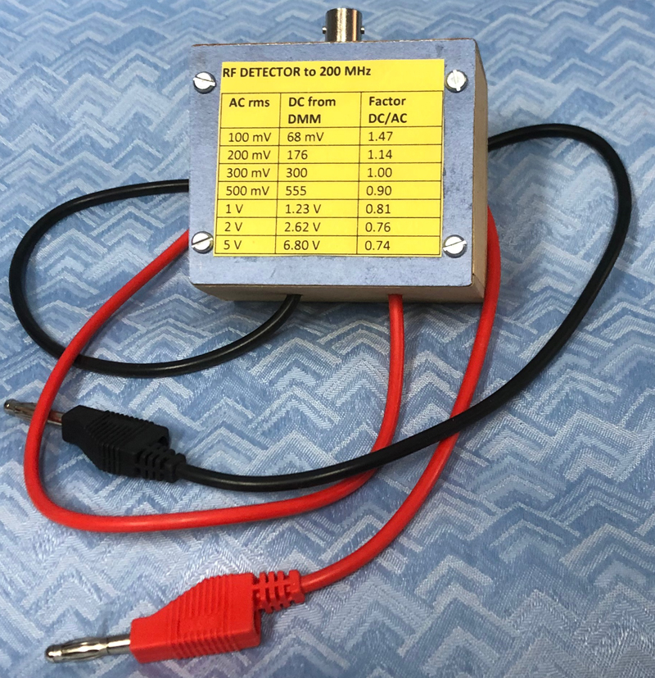
Figure 3 BNC version
For the probe I used a piece of 20 mm PVC conduit. The nose piece was turned from a piece of aluminium round bar with 3.3 mm centre hole tapped M4. The probe itself was made from 5/32 inch diameter brass rod threaded M4 at one end. For the inner connection I used a 4 mm solder lug secured via a screw. The earth connection is via a piece of hook-up wire with a crocodile clip via a transverse hole in the PVC tube. I turned up a Delrin plug for the back end with a centre hole to accommodate a length of shielded microphone cable.
The box version is straight forward.
The Schottky diode is a non-linear square-law device, particularly at low voltages which means that the probe needs to be calibrated and that is the tricky part. There is also some transmission loss in the diode.
Table 1 has the calibration chart that I made.

Input RF  voltage rms | Output DC  mV/V | DC/AC  factor | AC/DC  factor
10 mV | 1.8 mV | 0.18 | 5.56
20 mV | 9.0 mV | 0.45 | 2.22
50 mV | 40 mV | 0.8 | 1.25
100 mV | 97 mV | 0.97 | 1.03
200 mV | 226 mV | 1.13 | 0.88
500 mV | 560 mV | 1.12 | 0.89
1 V | 1.22 V | 1.22 | 0.82
2 V | 2.61 V | 1.30 | 0.77
5 V | 6.73 V | 1.35 | 0.74
10 V | 14.1 V | 1.41 | 0.71
You can interpolate as necessary.
Please note that this is not an accurate measuring method but rather than for use to get approximate results.

John Clark ARMIT January 2023
john@ausbow.com.au

