A 2 valve multi-band regenerative receiver
About sixty years ago, when I was young, I built an AM/SW valve regenerative radio using 1940s octal valves, specifically a 6SH7 for the regenerative detector and a 6V6GTfor the audio amplifier and plug-in coils. I particularly wanted a radio for SW. This radio had a 150 volt a side power transformer with a valve rectifier. The circuit came from an old Radio Television and Hobbies (R,TV&H) magazine circa 1950. However I have not been successful in finding the circuit and I wanted to re-visit my misspent youth.
Finally, after a long search I was able to purchase a job lot of old R,TV&H magazines which included an article entitled “A Simple Receiver for Three Bands” by Maurice Findley, May 1957. This circuit utilised the more modern twin pentode/triode 6U8 and a Hartley style oscillator with a 6X4 rectifier tube. The circuit also incorporated band-switching.
I was able to purchase a couple of each of the 6SH7 and 6V6GT and also a couple of brand new octal sockets. As luck would have it I was also able to source a small 150V a side power transformer but I had no rectifier tube. So the decision was made to re-design the power supply using silicon diodes. I also used a separate filament transformer. I was also able to source a speaker output transformer – at great expense.
I also decided not to utilise band-switching but rather plug-in coils.
Figure 1 depicts the final re-designed circuit.
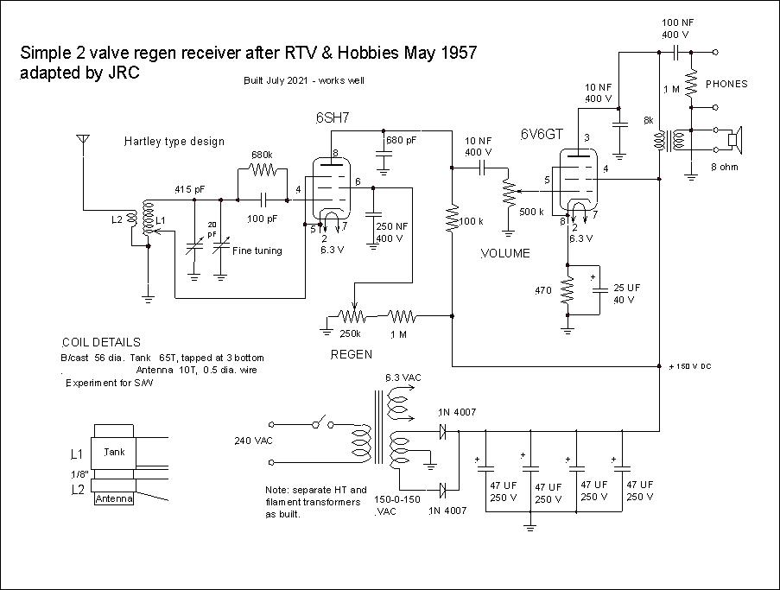
Figure 1 circuit schematic

Basically I just copied the original circuit complete with component values but just substituting the 6SH7 and 6V6GT tubes. I also added a fine tuning variable capacitor. I also changed the coil dimensions. I wanted to use plug-in coils and I build my own plugs and sockets. I needed a 4 pin plug and socket arrangement. I first built the broadcast band coil on a 56 mm OD length of PVC pipe with 10 turns for the antenna coil of 0.5 mm diameter enamelled copper wire and the tank coil with 65 turns tapped at 3 turns from the earthy end, again with 0.5 mm diameter wire.
The receiver worked first time with the broadcast coil – much to my surprise.
One problem with the Hartley coil design is that there is the need for a tap on the tank coil. This is not required for the more traditional Armstrong coil arrangement which has separate antenna, tank and tickler windings. This makes for some mechanical complication, particularly for coils with only a small number of turns. I still need to experiment with the SW coils and I wanted to cover from about 6 to 16 MHz. with hopefully only one coil.
I did not want to use the drum and cord type dial arrangement but rather just a standard large knob and cursor.
For the chassis I used a single piece of aluminium sheet supported by a wooden sub-frame using 45 x 19 mm pine. I also used another piece of aluminium sheet for the front panel. The loudspeaker was mounted on the chassis to the side and I made a wooden box cover which was hinged at the rear to provide coil access. The hinges were simple pin-type using screws.
Care is needed to use appropriately rated components for the high voltages involved unlike those used in my semiconductor circuits.
See photos of layout and front panel.
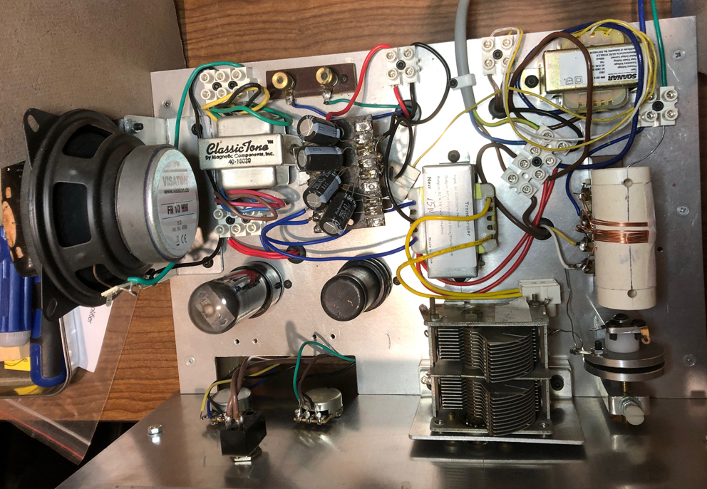
Figure 2 Inside layout

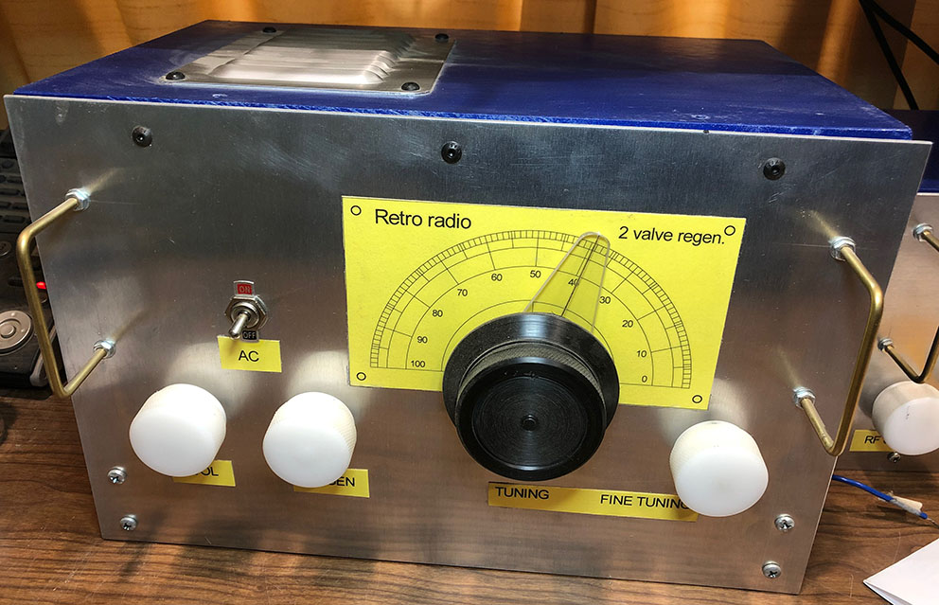
Figure 3 Front panel
The performance was not spectacular and could do with greater audio gain from the loudspeaker, however I was able to tune in to some regional AM stations. The results were satisfactory given that the design is not optimised and there are only 2 valves.

John Clark ARMIT January 2023
john@ausbow.com.au

