Homemade headphones - cans
I have several pairs of vintage high impedance magnetic headphones but they are getting to be scare, expensive and sometimes in poor condition. Also I have had several instances with broken cable terminations. So I decided to make my own for everyday use. My first attempts were unsuccessful. I tried to wind coils with 43 gauge enamelled copper wire about permanent magnets with homemade armatures. Working with this hair-like wire is a nightmare!
So plan B was to utilise telephone receiver inserts which are available for sale or can be harvested from old phone handsets.
Small tuna tins are just perfect for housing the receivers - so we have cans literally! The tins incorporate a useful inside lip for mounting the receivers, however they are smaller in diameter for the main body (typically about 38.5 mm) whereas the inside tin diameter is about 62 mm. So you need to make adaptor discs from say 1 mm thick aluminium sheet. Glue each receiver into the discs with epoxy.
The phone receivers have handy screw terminals. You need to fit reasonably long wire tails before the mounted receivers are glued into their cans. But first we need to make suitable terminations on the backside of the cans so as to securely anchor the leads. You also need to make some sort of stirrup arrangement, adjustable pivots and headband. Figure 1 depicts what I have done.
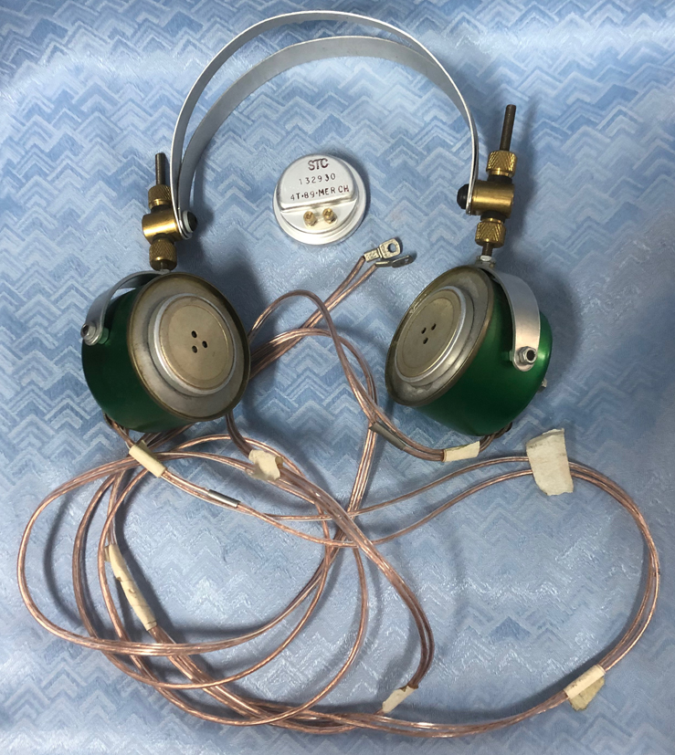
Figure 1 homemade headphones
The cable terminations need to be robust and care is needed to avoid any sharp-edged holes where the tail wires come through the cans. You need to wire-up the 2 receiver units in series since each receiver is not very high in impedance. I use split loudspeaker cable and find that this works just fine.
I use these headphones regularly for a variety of purposes and find that they work very well and are pretty robust.
I can supply working drawings for these headphones if required.

John Clark ARMIT January 2023
john@ausbow.com.au

