A simple AM broadcast regenerative receiver for DX
This project resulted in the quest to find a simple but sensitive AM broadcast DX (distance listening) receiver. The basic circuit comes courtesy from www.electroniq.net/radio-frequency/am-regenerative-receiver.html. with a single transistor. This circuit is very sensitive and will support headphones. However I needed to provide more “grunt” and decided to add a homebrew RF pre-amplifier. This resulted in the logging of some 60 stations with distances of up to 1600 km as the crow flies. Figure 1 depicts the basic receiver circuit.
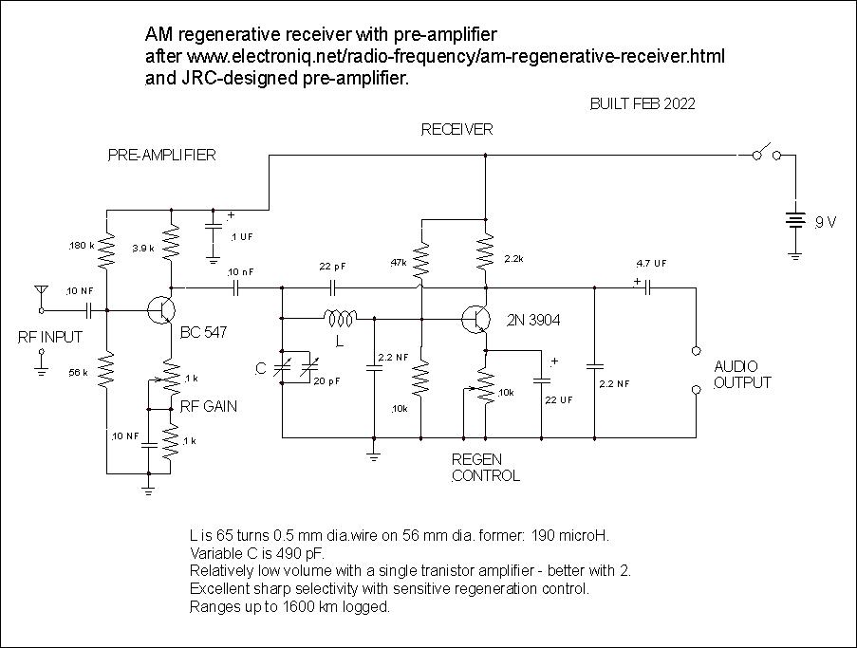
Figure 1 Basic circuit
The beauty of this circuit is that there is only a single coil winding unlike the more traditional Hartley or Armstrong designs which makes for greater simplicity – no “tickler” coil.
I have built several radios with this design all with a variety of audio pre and power amplifiers. I build with old-fashioned tag or barrier strips. Note that there is a 20 pF trimmer variable capacitor for fine tuning although this is not essential. I use a home brew plug and socket system for the tank coil. Coils are wound on PVC pipe.
Operation is fairly straightforward once you master the regen. control. You need maximum RF gain for distant stations and back off for the strong locals. Regenerative receivers are remarkably sensitive and this circuit also has excellent selectivity.
You need to have a random long wire antenna and a good earth.
The incorporation of the RF pre-amplifier also serves to de-couple the oscillator from the antenna reducing any unwanted radiation.
Fading is always an issue with AM signals from long distances and I have not had any success with automatic gain controls (AGC). Unfortunately it comes with the territory.
Figure 2 depicts a possible high gain audio pre-amplifier circuit which should be sufficient to drive a 1W power amplifier.
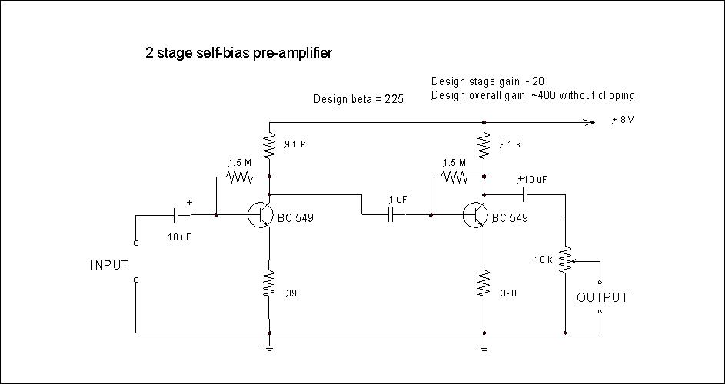
Figure 2 Possible audio pre-amplifier circuit

John Clark ARMIT January 2023
john@ausbow.com.au

