A 2 Watt Class-AB audio power amplifier
I found this circuit almost by accident for an interesting 2W class-AB power amplifier in an article entitled “2 Watt Class-AB Audio Amplifier by BD139 and BD140” https://www.eeweb.com/2-watt-class-ab-audio-amplifier-by-bd139-and-bd14, posted by EEWeb January 14, 2016. The published circuit diagram is depicted in Figure 1.
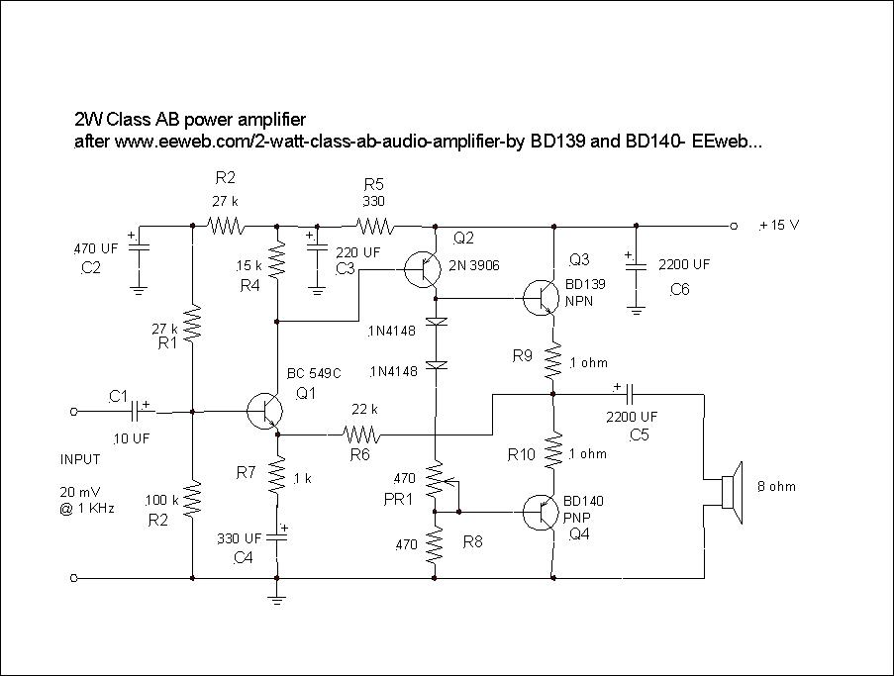
Figure 1 Original circuit diagram
There was very little explanation in the article, save to say that the amplifier claims to provide low harmonic distortion and low current across the power transistors, and there were not many comments posted so I was unsure whether anyone had actually built the amplifier. Unfortunately there are a lot of circuits posted on the internet but many do not work and I was initially sceptical. Upon analysing the circuit there is no DC return path for Q1 as C4 is in series with the emitter resistor R7. By my reckoning the circuit will not work and C4 should be in parallel with R7. Q1 is a high voltage gain common emitter driver stage but with a beta of 420. However by my calculation bias resistors R1 and R3 are way too small and should be about 470K each. R2 is OK. Q1 collector current is 0.5 mA which agreed with collector resistor R4.

So I re-designed the circuit as per Figure 2.
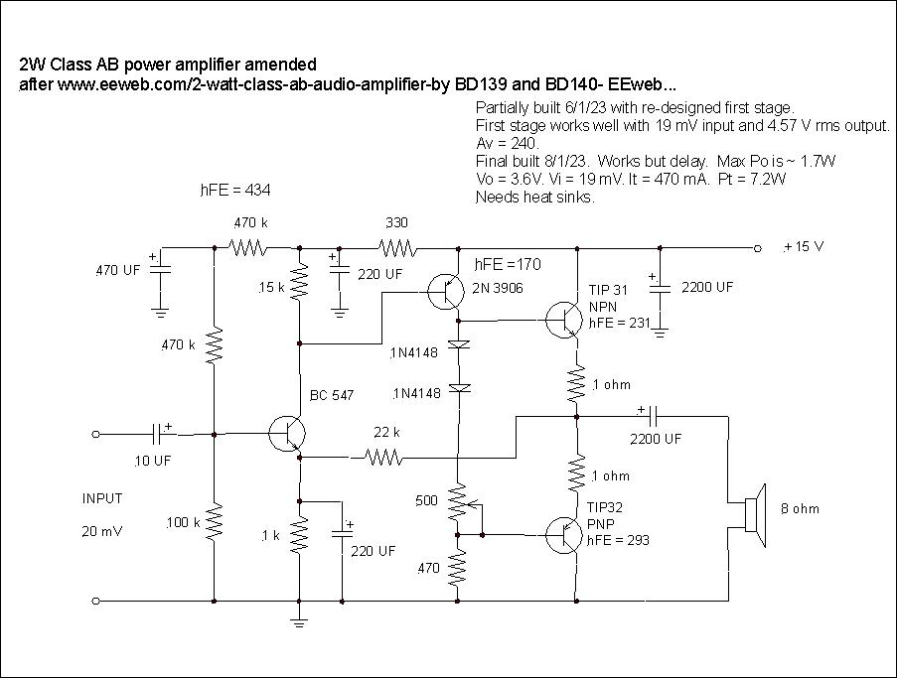
Figure 2 Re-designed circuit
I was now intrigued to know whether the re-designed Q1 stage would work – so to build. I found a suitable BC547 with a beta of 434. (The BC109C is identical to a BC549C except for the package). To my delight the re-designed stage worked exactly as predicted with a maximum input voltage of 19 mV, an output voltage of 4.6V and a stage voltage gain of -240. (By my calculations you need about 4 volts of output signal over an 8 ohm load to achieve an output power of 2W rms). So all looked good.
I then needed to build the rest of the circuit but I was struggling to find suitable complementary output transistors as I did not have any BD139/140s. In the end I used a TIP 31 (beta = 231) and TIP 32 (beta = 293). The amplifier worked although there is a delay before amplification occurs, but the initial results had 3.6V output with 19 mV input and 1.73 W output and there is an uneven power sharing between the output transistors and not optimised. The power transistors need small heat sinks. Interestingly the circuit employs a feedback loop via the 22k resistor R6 and this was needed. (R6 was temporarily disconnected with poor results).
I then connected the output of one of my homebrew FM super-regenerative receivers to the amplifier, which worked just fine. The long term power consumption was 3W with 200 mA current which is good, but probably not at full output power.
You need to set up most class AB amplifiers with an oscilloscope and this was no exception.
One good aspect of this amplifier is that the input signal voltage is only 20 mV which possibly obviates the necessity to have a pre-amplifier.
I was not able to measure the total harmonic distortion due to the lack of suitable test equipment.
The EEweb article states that the amplifier can be realised for 5W but with higher total harmonic distortion, so I decided to re-design it accordingly. Figure 3 depicts that attempt.
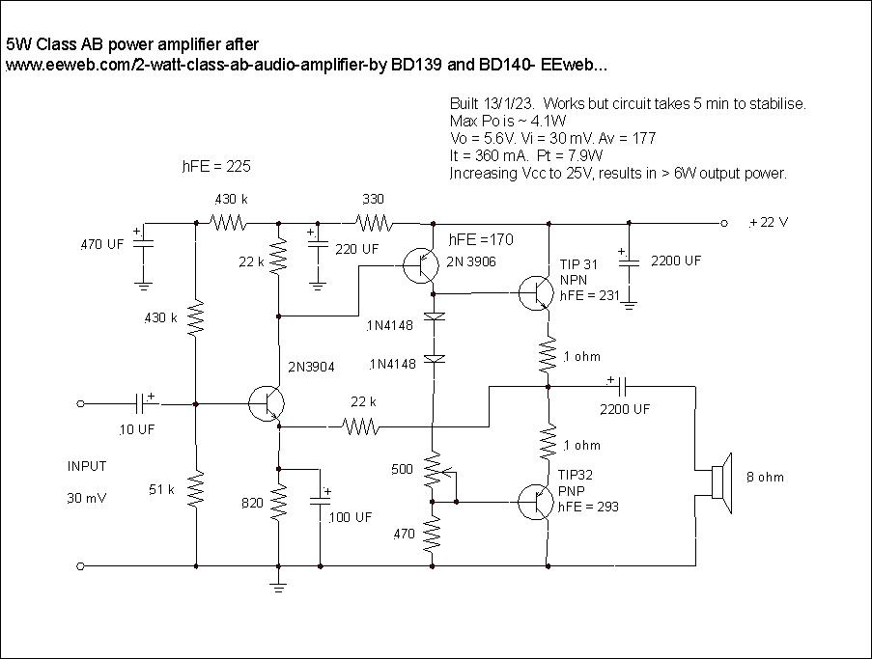
Figure 3 5W version
Note that I used a 2N3904 with beta = 225 for Q1. (There is no need to use a high beta for a high voltage gain stage). Maximum output power was ~ 4.1W. Reducing Q1 emitter resistor value will increase the voltage gain so as to achieve 5W output for Vcc = 22V. (Note that for 5W you need to increase Vcc). Increasing Vcc to 25V resulted in >6W output power.

So in conclusion the modified circuit essentially met all the criteria and I am certain that with properly matched output transistors and some tweaking the results would be better. The same comments are applicable to the 5W version. Note that both amplifiers needed 5 minutes to stabilise to maximum output power. These are useful additions to my collection.

John Clark ARMIT January 2023
john@ausbow.com.au

