100 MHz collinear antenna for FM
This project evolved to satisfy the need for greater signal strength to feed my home brew FM receivers. I only build using discrete components, constructed on old-fashioned tag strips. Having built a number of regenerative, super-regenerative and a pulse counting superhet sets, only one really worked and even then reception quality was somewhat lacking. I live 85 km south of Adelaide, South Australia and we have a range blocking both TV and FM broadcast reception - a challenge, even for the regional stations. I particularly wanted to receive ABC Classic FM (32 Watts transmitter power) which cannot be achieved with my PANASONIC set with a ¼ wave telescopic whip.
None of the sets worked with simple ¼ wave whips and only one was reasonably happy with an external folded dipole. I then looked at discone and collinear arrays. The discone is not all that easy to realise and bulky at 100 MHz. The collinear looked a better prospect for home construction, however there are some length issues to deal with if you are looking for high gain at 100 MHz.
I settled on the basic design and construction courtesy of Karl Shoemaker “Collinear antenna building” www.srgclub.org/CollinearAnt-HomeBrew and “Coax collinear Antenna dimension calculator”, https://jeroen.steeman.org/Antenna/collinear-coax. My simple super-regen set called for a 75 ohm input impedance so I started about trying to source suitable RG11 coaxial cable for the elements. But alas trying to source “proper” RG11 with a copper outer braid is both difficult and expensive. Most of the available branded RG11 cable has a copper inner and a steel/aluminium outer. In order to build a collinear array you need to solder inners to outers. So what to do? I then looked at using ANDREW 1/2 inch HELIAX, but it now only comes in 50 ohm. I settled on a 50 ohm design. The 50 ohm HELIAX has a copper cladded aluminium inner core and foam dielectric with a velocity constant of 0.88. This means that the elements all need to be a bit longer than using either RG 11 or RG8.
According to the theory you can have 1, 2, 4 or 16 x ½ wavelength elements. The final design was for 2 x ½ wave elements with a ¼ wave element top and bottom and a ¼ wave solid brass whip on top of that. See Figure 1. The whole of the HELIAX structure was to be housed in a length of 65 mm PVC pipe as a radome. The overall length of the radome needed to be about 4.5 m. (PVC pipe comes in 6m lengths). The electrical length of ½ wave elements was 1320 mm and the ¼ wave elements 660 mm with a 750 mm whip. I was lucky enough to buy a 30 foot length of HELIAX cable terminated with type N connectors. This was ample for both the elements and about a 4 m tail cable. Since the antenna was only to be used for receiving, there was no need to tune the tail cable. The ¼ wave whip is mounted on a 65m PVC pipe cap as shown below.

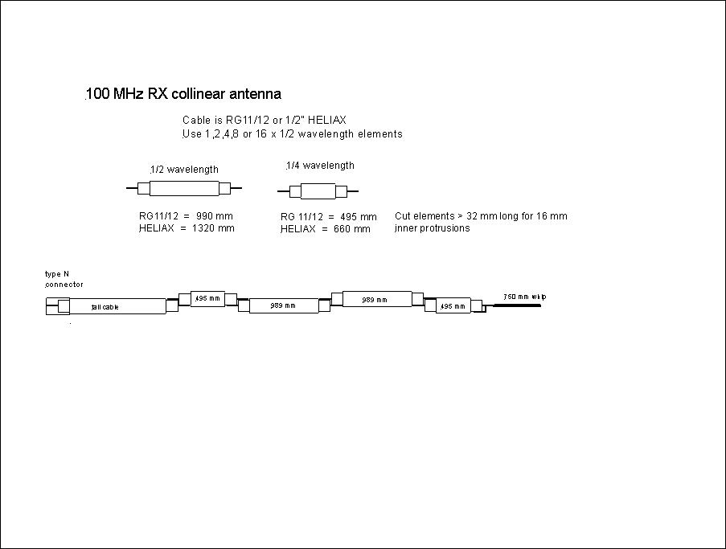
Figure 1A. Antenna schematic diagram
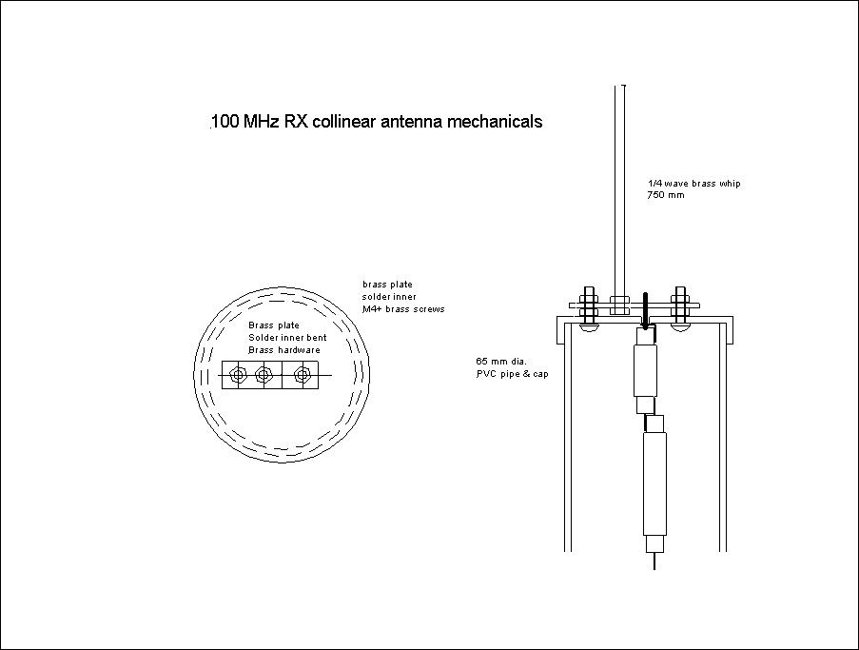
Figure 1B Antenna mechanicals

Working with HELIAX is interesting and I was a bit rusty given that it is over 50 years since I last used it! First cut off enough outer jacket and then very carefully use a small wheeled-type tube cutter to sever the outer – do not cut too deeply! The next challenge was to remove the severed outer piece without damaging the inner. I found that using an angle grinder to just lightly touch the outer generated enough heat to allow removal with a pair of pliers and then pare off the remaining foam. You need to allow about 16 mm extra length on the end of each element to allow for the overlapping joints. The next challenge is to make the element joints. I settled on binding each joint half using 22 gauge tinned copper wire and then soldering. (You need a heavy electric soldering iron – about 150 Watt). (See Figure 2). After the whole assembly is made cover each joint with adhesive type heat shrink tube to weather proof and provide additional strength. Note that it is also necessary to join the inner of the uppermost 1/4 wavelength inner to the outer using a piece of folded 1 mm diameter bare or tinned copper wire.

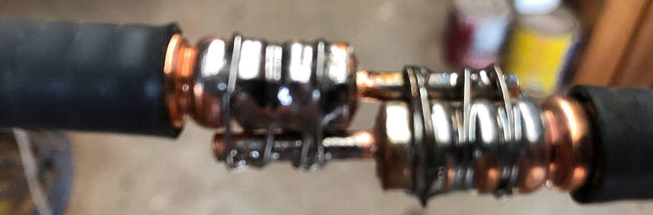
Figure 2 Element joints
There was another issue to deal with and that is how to support the assembly inside the radome. I decided to make some discs from high density polythene packaging material and these would be slipped over the cable between the element joints before assembly. The discs were fabricated from thinner sheet to make discs about 20 to 25 mm thick. The discs were cut so that they were a loose push fit inside the PVC pipe, except for a couple cut to be tighter for the tail cable end. The discs needed to be secured with collars on either side to prevent being moved during the insertion of the element assembly. I turned some wooden flanged collars and secured them with duct tape. (See Figure 3). Once the antenna is in situ there will be vibration and wind loading and it is important to cushion any movement of the element assembly particularly since the total weight is supported via a solder joint of the uppermost coax inner via a brass plate on the top cap. The inner diameter is about 3.5 mm in diameter. The whip itself was made from 5/32” (4 mm) diameter brass rod which is threaded at the bottom M4 and secured via a threaded nipple and nut onto a brass strip. The strip is secured via 3/6 BSW brass screws, washers and nuts. (See Figure 4 photo). The PVC cap has a 3.5 mm hole drilled in the centre to accept the topmost inner and passed through the brass strip and soldered. After final assembly in the radome all screws need to be sealed with epoxy or similar to stop loosening via vibration. Similarly the centre hole in the cap needs to be sealed with silicone or similar to prevent moisture ingress. All of the hardware associated with the ¼ wave whip is made from brass to avoid effects of dissimilar metals and corrosion.
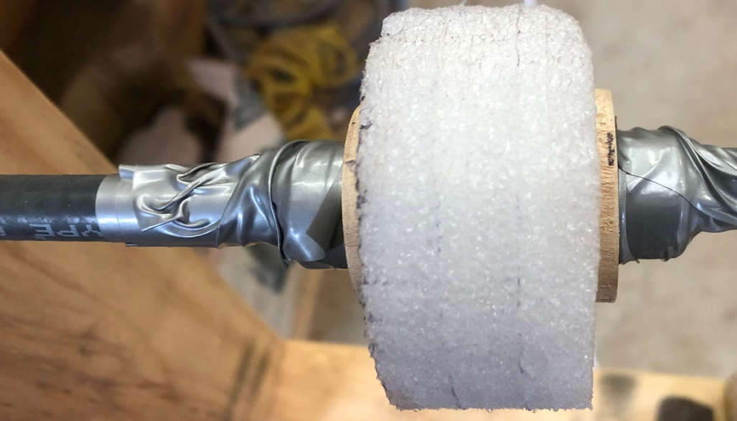
Figure 3 Polythene disc and secured wooden flanged collars
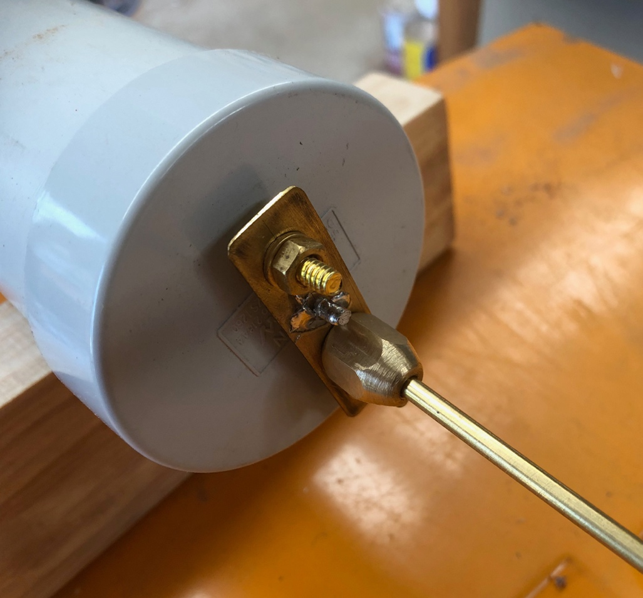
Figure 4 Top cap assembly
Some thought was needed to control condensation within the radome and it was considered that because the element assembly was adequately weather-proofed there was no need.
You need a lot of space to assemble this antenna and it is awkward to make the solder joints between elements. Consequently I made a couple of simple wooden jigs clamped onto a saw horse. The jigs incorporated wooden clamp blocks to align the HELIAX. Before the joints are soldered, you need to ensure that all the foam discs, wooden collars and heat shrink tube is fitted. (See Figure 5 photos). Remember to fit the bottom pipe cap onto tail cable before the last cable joint is made.
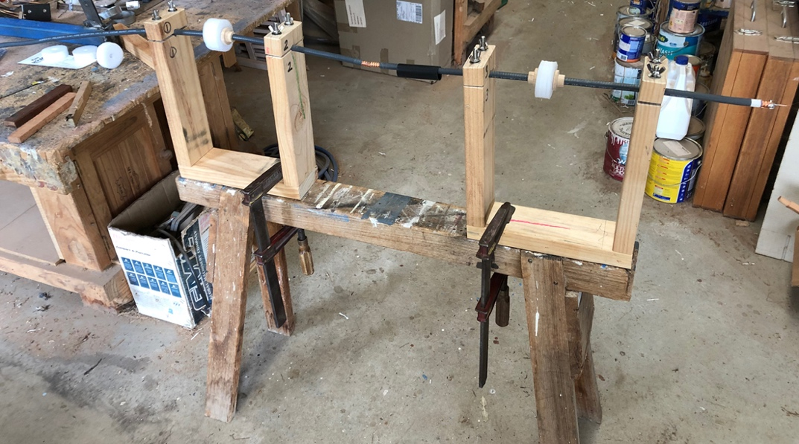
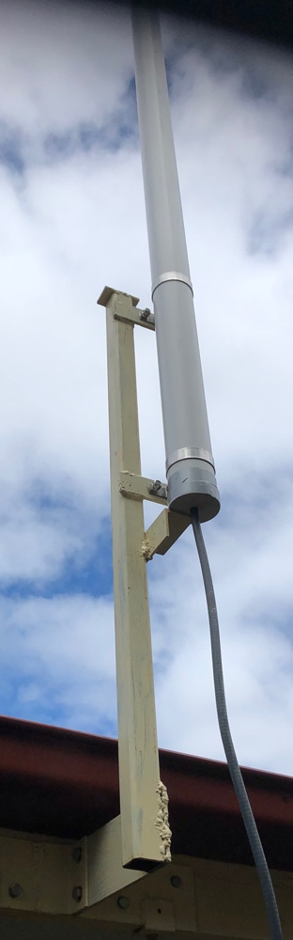
Figure 5 Element joint jig and assembly
Initially I expected that it would be necessary to introduce a piece of cord down inside the radome and tie it close to the top of the uppermost coax element and carefully tow the element assembly from the bottom of the radome using the cord. However this was found not to be needed since the cable assembly is stiff enough and there was not a lot of friction due to the foam plastic discs. Once the assembly is installed you need to solder the inner to the brass strip on the cap assembly and fit the cap down onto the pipe. It is probably not necessary to use pipe cement.
The antenna was to be mounted on the bargeboard of the roof eaves and this required the making of a sturdy steel weldment. Erecting the antenna would be tricky given its length and weight. I bought a pair of 65mm stainless steel pipe clamps. These were bolted onto a couple of brackets about 450 mm apart. The main mount is a piece of 40 mm RHS steel tube. To support the weight of the antenna, and make erection easier, I welded a piece of angle below the lower clamp. See Figure 6. The antenna was bolted in situ before erection to secure the clamp bracket position. The clamps were left on the radome so as to make the erection easier. Nonetheless erection is awkward without a crane! When routing the tail cable ensure that there is a drip loop to stop rainwater coming along the cable to the connector.
Figure 6 Mounting arrangement
Testing was to be done via a Vector Network Analyser, however this is easier said than done. The antenna was successfully erected and connected to my Charles Kitchin inspired super regen receiver and to my delight it worked better than with the folded dipole. ABC Classic FM came in with a reasonable, but not strong signal, enough to be acceptable. Tuning a super regen is fussy and there is some drift which needs adjustment of the regen and squelch controls.
Overall the project was a success, but I am not sure what actual gain was achieved or the return loss. Theoretically, the gain should be 3dB better than a single dipole – about 5 dBi.
John Clark ARMIT, john@ausbow.com.au November 2022

