Designing, building and testing practical Common Emitter small signal amplifiers
There are a great many articles published on the internet for designing small signal amplifiers but most tend to be more theoretical than practical. There is also a great deal of misinformation published. This work is intended to provide some practical information which focuses on Common Emitter (CE) amplifiers using discrete components and construction methods which do not require printed circuit boards.
There are two types of CE amplifiers as voltage divider bias and self or common collector bias. Most of the texts tend to focus on the former.
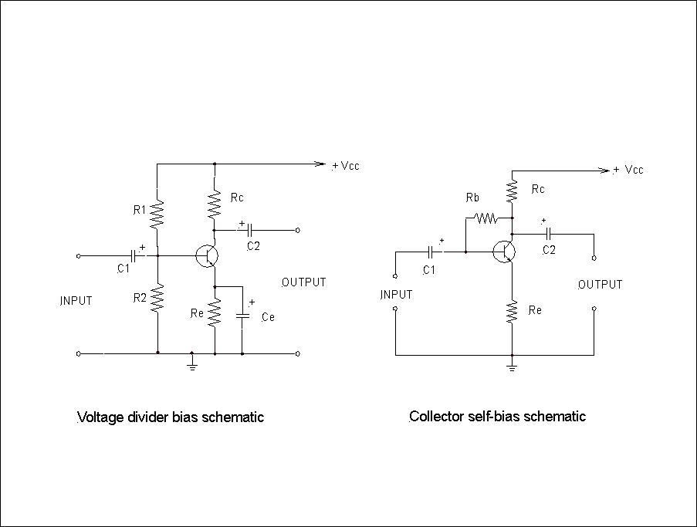
Figure 1 Voltage divider and collector self-bias schematic diagrams
Figure 1 depicts NPN Bipolar Junction Transistors (BJT) which require a positive power supply. If using PNP transistors use a negative supply.
CE amplifiers are Class A type with characteristics of high input and high output impedance. They are by far the most common types. Voltage divider bias amplifiers use more components but are largely independent of transistor current gain characteristics (hFE or beta). Self-bias designs are easier to design and can have much more predictable and perhaps higher voltage gain (Av).
When designing CE amplifiers the most important parameters are power supply voltage (Vcc), collector current (Ic), hFE and required Av. Perhaps counter intuitively hFE has absolutely nothing to do with Av. hFE values can vary significantly between individual transistors of the same type. We need to understand that a BJT is fundamentally a current amplifier rather than a voltage amplifier.
When I first started to learn how to design small signal amplifiers I did not know where to start. The starting point is to define Vcc and then Icmax. Vcc will depend on what signal output voltage is required, remembering that the AC signals are superimposed on the DC voltages. The collector/emitter voltage (Vce) is set at Vcc/2 which defines the mid or quiescent operating poin, that is if Vcc is 9V, then Vce is 4.5V and the maximum output signal without clipping is 4.5V peak to peak or 3.18V rms. In reality you should see a little less given component variation. (You need to design for a greater output voltage to allow some “headroom”).
Typically Icmax would be a few mA or even less. This is essentially a nominal value which the designer selects.
Common collector design example
We will start with the design example of a common collector self-bias amplifier since it is simpler.
Our basic design criteria are Vcc = 9V, Icmax is 1.15 mA, hFE is 150 and Av is 10.
So Vce is 0.5 * Vcc = 4.5V
Rc = Vce / Icmax = 3.9k
Now base voltage Ib = Icmax /hFE = 0.008mA
Now Av ~ Rc/Re (ignoring the internal device emitter junction resistance)
Therefore Re = 390 ohm (Rc/10)
And Vre = Icmax * Re = 0.45 V
And Vb = Vbe + Vre = 0.7 + 0.45 V = 1.15 V (Vbe is constant)
Now Rb = (Vce – Vb) / Ib = (4.5 – 1.15)/0.008 = 419k
So we have for our example amplifier:
Rc = 3.9k
Rb = 430k (may need to be varied to optimise results, particularly if unsure about the value of hFE)
Re = 390 ohm
Now you will see that the value of Rb is highly dependent on hFE, so it is important that hFE is measured or known exactly.
Re can be zero but that does not mean infinite Av given the internal device resistance is perhaps of the order of 10 ohms.
Coupling capacitors C1 and C2 will depend on the frequencies to be handled by the amplifier. For audio frequencies a value of around 1 microFarad is typical but not critical. Note the polarity if using electrolytics.
There are some simplifications used in this design and the measured Av will be little less than calculated, so Re could be a little less if needed.
Appendix 1 contains a calculator outline which you can put into an EXCEL spreadsheet.

Voltage divider bias example
Our design criteria are similar to that used for the common collector case.
Vcc, hFE, and Icmax are the same.
Rule of thumb states that Vre should be about 0.1 * Vcc for stability but for this example
Vre = 0.045 *Vcc = 0.405V
Rc = 3.9k as before
Ib = 0.008mA as before
Rule of thumb says that the “bleed” current in the voltage divider R1 and R2 should be 10 * Ib
Therefore R2 = (Vre + Vbe) / (10 * Ib) = (0.405 + 0.7) / (0.08) = 14.4 K
And R1 = ((Vcc-(Vre+Vbe)) / 11 *Ib = 93.6 k
Vb = 10 * Ib * R2 = 1.1V
Re ~ 390 ohm as before
Av ~10 for low frequencies (for Ce effectively open circuit or omitted)
Ce needs to have a reactance of approximately Re/10 at the frequencies of interest. For audio frequencies Ce may be say 220 microFarad. Ce is used to significantly increase Av while maintaining appropriate DC conditions. Depending on the required amplifier bandwidth the output level versus frequency will not be level due to the reactance of Ce in combination with Re.
It should be noted that because of the voltage divider, hFE is not critical and a nominal or average value can be used provided that the ratio of R1/R2 is preserved. (In this case R1/R2 = 6.5).
So for our practical amplifier example:
Rc = 3.9K
Re = 390 ohm
R1 = 15k
R2 = 100 k
C1 and C2 are as per before.
Again, there are some simplifications with these calculations.
Appendix 1 contains a calculator outline which you can put into an EXCEL spreadsheet.

Amplifiers in cascade
You can connect multiple single stage small signal amplifiers in cascade as required, but the inter stage coupling capacitors cannot be electrolytic types.

Building small signal amplifiers
Experimenters need to have a robust and effective prototyping test bed, particularly if the ultimate job will be realised in a printed circuit board (PCB). There are several commercially available prototyping boards which all rely on mechanical connections and this can be problematical. The author only uses old fashioned solder tag or barrier strips for all construction including prototyping. This allows easy modifications. Also old-fashioned breadboard construction has never really gone out of style! The most common problems relate to poor connections or wrong routing. BJT s are particularly robust but you need to be careful with old electrolytic capacitors. Barrier strip construction is satisfactory for frequencies well into the VHF range provided that you keep all leads short.
Figure 2 depicts a 3 stage self-bias audio amplifier with barrier strip construction.
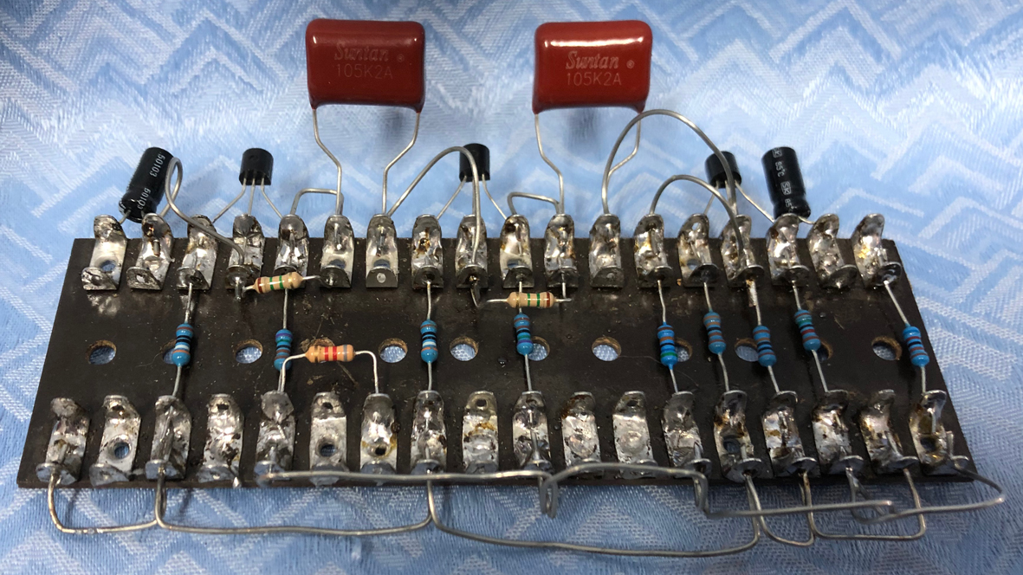
Figure 2 3 stage self-bias audio amplifier
Testing
Following construction it is wise to double check the circuit wiring and visually inspect all connections before applying supply voltage.
Using a digital multimeter (DMM), check all the voltages around the transistor.
Ideally you need an appropriate signal generator and an oscilloscope to check waveforms and clipping. Increase input level until the output waveform starts to flat at the top and/or bottom of the sinusoid. (The onset of clipping will usually not be at the same input level for both sinusoid peaks). You can check the maximum voltage gain at the point where the sinusoid is just short of clipping. For audio you can measure the input and output voltages with a DMM at say 1 KHz. For RF you need an RF probe connected to the DMM or a RF voltmeter.

John Clark ARMIT
December 2022
john@ausbow.com.au
Appendix 1 Collector self-bias design calculator outline
The following tables may be useful to create EXCEL spreadsheets for both the design of collector sel-bias and voltage divider amplifiers.

Column A | Column B formulae | Column C comments
A1 |  | Select Vcc volts
A2 | = A1/2 | Vce volts
A3 |  | Select Icmax mA
A4 | = A2/A3 | Rc kohm
A5 |  | Select hFE
A6 | = A3/A5 | Ib mA
A7 | = 0.7 + A10 | Vb volts
A8 | = (A2 – A7) / A6 | Rb kohm
A9 |  | Select Re kohm = Rc/Av
A10 | = (A3 * A9) / 1000 | Vre volts
A11 | = A4 / A9 | Approx.. Av
Table 1 Collector self-bias design calculator outline

Column A | Column B formulae | Column C comments
A1 |  | Select Vcc volts
A2 |  | Select hFE
A3 | = A1/2 | Vce volts
A4 | = A1/10 | Vre volts ~ 0.1 * Vcc
A5 |  | Select Icmax mA
A6 | = A3/A5 | Rc kohm
A7 | = A5/A2 | Ib mA
A8 | 0.7 | Base/emitter junction volts
A9 | = (A4 + A8) /(10 * A7) | R2 kohm
A10 | = (A1 –(A4 + A8)) / (11 * A7) | R1 kohm
A11 | = A10 / A9 | R1/R2
A12 | = | Select Re kohm
A13 | = (10 * A7 + A7) * A9 | Vb
A14 | = A6 / A13 | Approx.. Av without Ce
A15 | = = A12 / 10 | Xce ohm
A16 |  | Select lowest frequency Hz
A17 | =1000000*(1 / (6.284 * A16 * A15) | Ce microFarads
Table 2 Voltage divider bias design calculator outline
Av for low frequency = Rc divided by the value of Re in parallel with Xc. An approximation for Av with such a value of Ce is Rc / 0.1 Re. Av for high frequency with Ce designed for lowest frequency will be very high, depending on the internal emitter resistance since Re is short circuited.

